1.91: 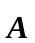and 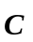are perpendicular, so 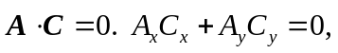, which gives 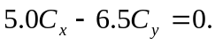
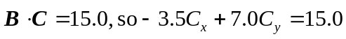
We have two equations in two unknowns 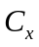 and 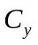. Solving gives 